Chapter 9, Problem 85.

The ac bridge circuit of Fig. 9.85 is called a Wien bridge. It is used for measuring the frequency of a source. Show that when the bridge is balanced,

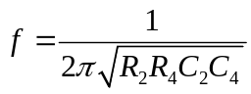

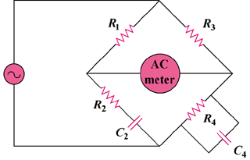

Figure 9.85
For Prob. 9.85.

